Reinforcement Learning with Dynamic Difficulty Adjustment in a Turn-Based Battle Environment
  - Joseph Nikhil Reddy Maramreddy
yue15@txstate.edu

1. Introduction
Difficulty balancing is one of the hardest problems in game design. If a game is too easy, players lose interest; if it is too hard, they become frustrated. Modern games often use Dynamic Difficulty Adjustment (DDA) to keep players engaged by adjusting the challenge level in response to how well the player is performing.
This project reproduces and extends the method presented in the paper “Go with the Flow: Reinforcement Learning in Turn-Based Battle Video Games” (Pagalyte et al., IVA 2020). The authors proposed using reinforcement learning, specifically SARSA, combined with a reward-swapping approach to adjust game difficulty automatically. Instead of manually tuning difficulty rules, their system encourages the agent to either win or lose depending on the player’s recent performance.
The objective of this project was to implement:
- A turn-based battle environment modeled after the paper.
- A human-like player agent.
- A SARSA reinforcement learning agent capable of DDA.
- Controlled experiments comparing:
  - SARSA with DDA
  - SARSA without DDA
  - A fixed Easy agent
  - A fixed Hard agent
The overall goal was to see whether the DDA agent learns to keep the game balanced and interactive, and whether the results resemble those in the original study.

2. Environment Design
The turn-based battle game implemented for this project follows the structure described in the reference paper. Both players (the human-like agent and the RL agent) start each battle with 75 HP. The battle continues until one side’s HP reaches zero.

2.1. State Representation
To keep the state space small, health values are grouped into five bands:
- 75 HP
- 51 - 74 HP
- 31 - 50 HP
- 16 - 30 HP
- 1 - 15 HP
The environment then compares the player’s band to the agent’s band to produce a 17-state model:
- States 0 - 4: equal HP
- States 5 - 9: agent has more HP
- States 10 -14: player has more HP
- State 15: player HP ≤ 0 (agent win)
- State 16: agent HP ≤ 0 (agent loss)
This model directly matches the structure described in the original paper.

2.2. Action Space
Both, the player and the agent, can choose from four actions:
Action | Description | Effect
Hit | Light Attack | 2 – 5 damage
Charge | Heavy Attack | 10 – 15 damage
Combo | Multi-hit Random Attack | (2 – 5 hits) * (2 – 5 damage)
Heal | Restore HP | + 10 HP
The randomness of attacks makes the game dynamic and prevents the agent from deterministic exploitation.

2.3. Turn Structure
Each turn proceeds in the following order:
- Human-like player chooses an action.
- Player action executes.
- SARSA or scripted agent performs an action.
- Agent action executes
- HP updates and new state is computed.
A battle can last anywhere from 6 to 40 turns.

3. Agent Designs
Five different agents were implemented to evaluate the role of DDA.

3.1. Human-Like Player Agent
Because real human participants were not used, a simulated human-like agent was designed. Its behavior is based on observations from the original paper:
- Strong preference for Charge and Combo
- Uses Heal when HP is low
- Rarely uses Hit
- Behavior includes randomness to mimic real players
This agent serves as the consistent “player” against all other agents.

3.2. SARSA Agent With Dynamic Difficulty Adjustment
The core of this project is the SARSA reinforcement learning agent. It uses:
- α = 0.1 (learning rate)
- γ = 0.99 (discount factor)
- ε = 0.3 or 0.5 (exploration rate)
Dynamic Difficulty Adjustment (DDA)
The main idea of the paper is that the agent should not always try to win.
Instead:
- If the player wins many times in a row, then, the agent starts trying harder (reward for winning is positive).
- If the player loses many times in a row, then, the agent makes itself easier (reward for losing becomes positive).
This was implemented by reversing the sign of rewards after a streak of 5 consecutive wins or losses.

3.3. SARSA Agent Without DDA (Ablation Study)
To understand whether DDA matters, a second SARSA agent was implemented with identical parameters but no reward swapping. This represents the “pure” RL approach.

3.4. Fixed Easy Scripted Agent
This agent follows a simple predictable policy:
- Heals often
- Uses weak attacks
- Rarely uses Combo
It serves as a baseline to show how a non-learning weak agent behaves.

3.5. Fixed Hard Scripted Agent
Opposite of the easy agent:
- Highly aggressive
- Prefers Charge and Combo
- Rarely heals
This shows how a difficult static agent performs.

4. Experimental Setup
Experiments were run over 3000 battles per configuration. This large sample size ensures statistical stability and reduces noise caused by the environment’s built-in randomness. All agents fought the same human-like player.
The following configurations were tested:
- SARSA + DDA (ε = 0.3)
- SARSA + DDA (ε = 0.5)
- SARSA without DDA
- Scripted Easy agent
- Scripted Hard agent
Data collected included:
- Win/loss rates
- Battle duration
- Player and agent action distributions
- Streak behavior (important for DDA)
- HP trajectories for sample battles

5. Results & Analysis
This section presents the performance of all experimental conditions using the updated large-scale evaluation of 3000 battles per configuration, closely following the evaluation methodology of the original paper. The larger experiment size provides more statistically stable estimates of win rates, pacing, and behavior trends.

5.1. Overall Win Rates
The following table summarizes the performance of each agent:
Agent Type | Player Win Rate (in %) | Agent Win Rate (in %)
SARSA + DDA (30/70) | 60.1 | 39.9
SARSA + DDA (50/50) | 67.0 | 33.0
SARSA No DDA | 55.9 | 44.1
Easy Agent | 98.7 | 1.3
Hard Agent | 61.9 | 38.1
Across all RL-based conditions, the three SARSA-based models produced player win rates between 55% and 67%, demonstrating that:
- The RL agent remains competitive without overwhelming the player.
- DDA does not cause instability or collapse in performance.
- The agent wins often enough to maintain tension, but not frequently enough to frustrate the player.
The scripted baselines behaved as expected:
- The Easy Agent is trivial to defeat.
- The Hard Agent consistently pressures the player and wins a substantial number of battles.

5.2. Battle Length
Battle length is an important measure of engagement, reflecting how long a typical encounter lasts and whether the agent’s decisions lead to unusually short or prolonged battles.
Configuration | Avg. Turns
SARSA + DDA (30/70) | 10.58
SARSA + DDA (50/50) | 10.67
SARSA No DDA | 9.89
Easy Agent | 12.14
Hard Agent | 9.27
Average battle durations fall between 9 and 12 turns, indicating stable pacing across all models. Notably:
- The Easy Agent creates longer battles due to frequent healing.
- The Hard Agent ends the battles more quickly due to aggressive moves.
- All RL conditions maintain nearly identical pacing, regardless of DDA.
This is consistent with the original paper’s findings that short, stochastic combat environments naturally converge toward stable encounter lengths.

5.3. Action Selection Patterns
Action distributions offer insight into how each agent develops behavioral preferences. Action distributions reveal learned behavioral tendencies for each agent.

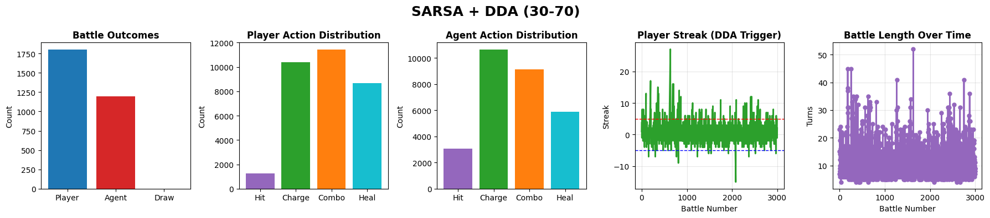
Figure 1: This plot shows the performance of the SARSA agent trained with Dynamic Difficulty Adjustment using a 30/70 exploration to exploitation ratio. The agent maintains balanced behavior with moderate win-loss fluctuations and consistent battle lengths. Action usage is varied, reflecting a stable and adaptive policy.
Experiment: SARSA+DDA(30-70)
- Total Battles: 3000
- Player Wins: 1802 (60.1%)
- Agent Wins: 1198 (39.9%)
- Average Battle Length: 10.58
- Player Action Counts: Counter({2: 11431, 1: 10374, 3: 8680, 0: 1257})
- Agent Action Counts: Counter({1: 10644, 2: 9138, 3: 5903, 0: 3057})

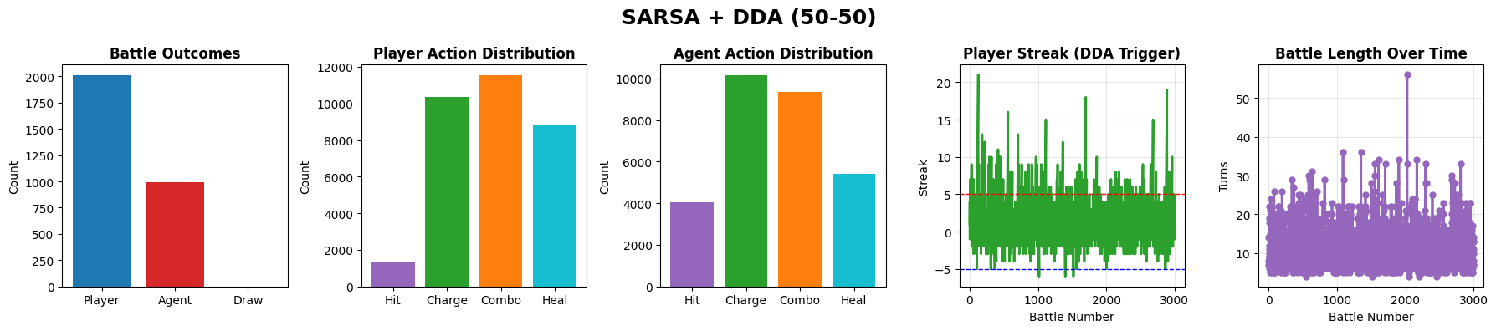
Figure 2: This plot illustrates the results of the SARSA agent using a 50/50 exploration to exploitation ratio. Despite higher exploration, the agent demonstrates similar win rates and pacing to the 30/70 model. The action distribution remains diverse, indicating the policy remains stable under increased randomness.
Experiment: SARSA+DDA(50-50)
- Total Battles: 3000
- Player Wins: 2011 (67.0%)
- Agent Wins: 989 (33.0%)
- Average Battle Length: 10.67
- Player Action Counts: Counter({2: 11544, 1: 10362, 3: 8788, 0: 1307})
- Agent Action Counts: Counter({1: 10156, 2: 9361, 3: 5420, 0: 4064})

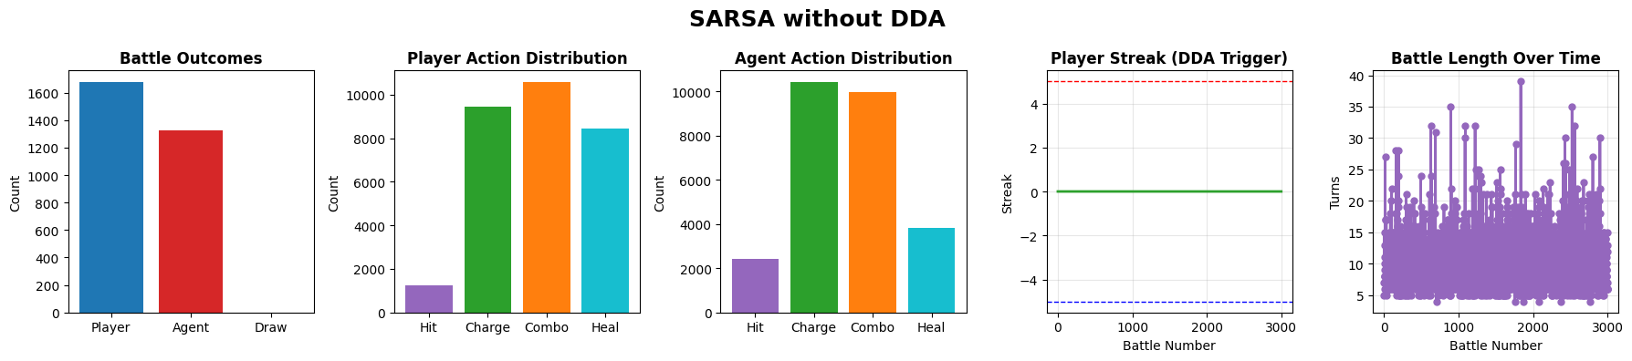
Figure 3: This visualization represents the performance of the SARSA agent trained without Dynamic Difficulty Adjustment. The win-loss pattern shows more pronounced streaks, indicating reduced adaptability. Battle lengths and actions are less balanced, reflecting a more rigid policy.
Experiment: SARSA-NoDDA
- Total Battles: 3000
- Player Wins: 1677 (55.9%)
- Agent Wins: 1323 (44.1%)
- Average Battle Length: 9.89
- Player Action Counts: Counter({2: 10582, 1: 9442, 3: 8431, 0: 1228})
- Agent Action Counts: Counter({1: 10428, 2: 9972, 3: 3843, 0: 2440})

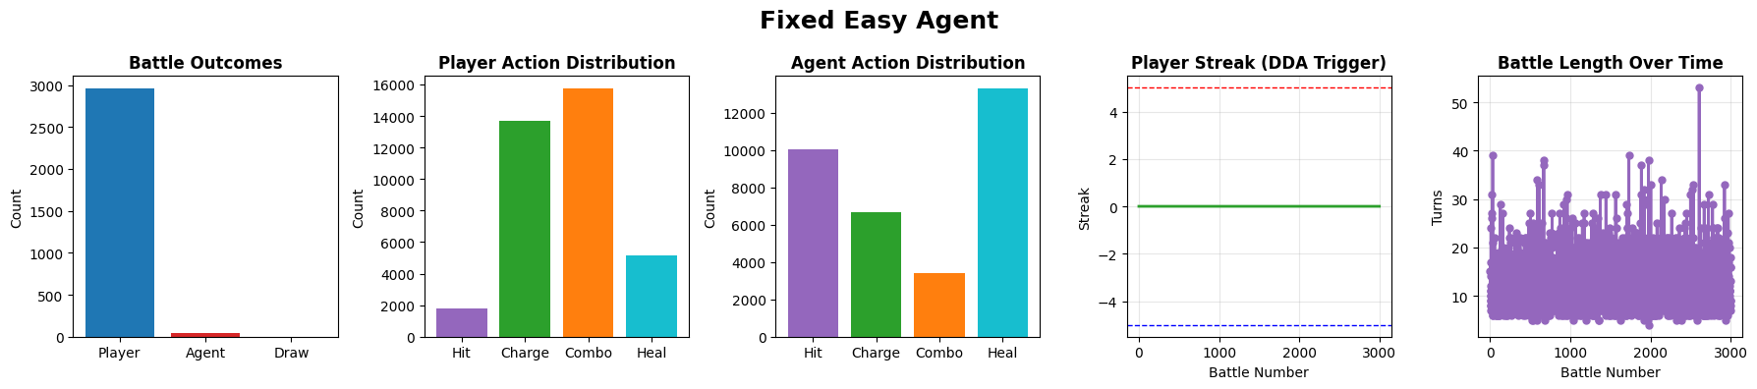
Figure 4: This plot shows the behavior of the scripted Easy agent. The player wins all battles, and the agent displays repetitive, predictable actions dominated by defensive choices. The resulting gameplay is low-challenge and stable across episodes.
Experiment: Fixed Easy
- Total Battles: 3000
- Player Wins: 2960 (98.7%)
- Agent Wins: 40 (1.3%)
- Average Battle Length: 12.14
- Player Action Counts: Counter({2: 15748, 1: 13714, 3: 5164, 0: 1791})
- Agent Action Counts: Counter({3: 13305, 0: 10056, 1: 6651, 2: 3405})

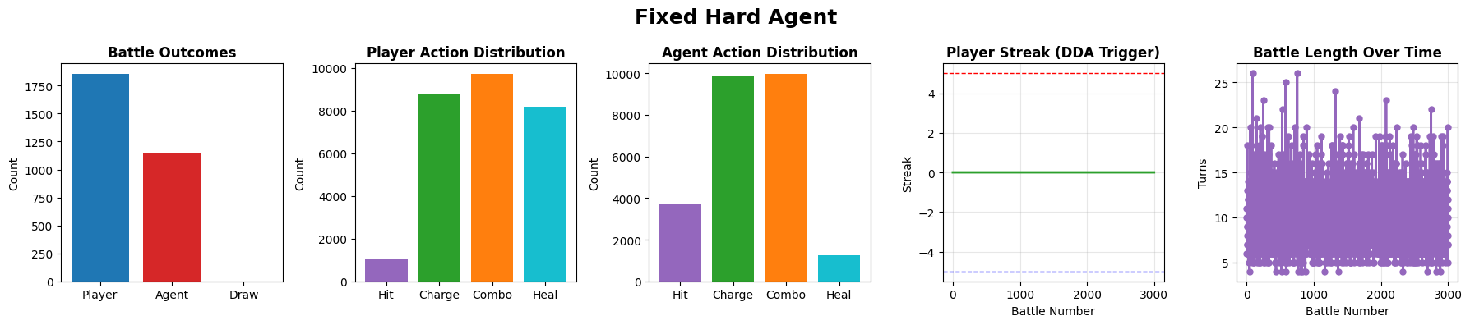
Figure 5: This plot displays the performance of the scripted Hard agent. The agent uses more aggressive actions, resulting in shorter battles and a higher number of agent wins compared to the Easy agent. The pattern is consistent and non-adaptive, reflecting a fixed difficulty design.
Experiment: Fixed Hard
- Total Battles: 3000
- Player Wins: 1856 (61.9%)
- Agent Wins: 1144 (38.1%)
- Average Battle Length: 9.27
- Player Action Counts: Counter({2: 9725, 1: 8813, 3: 8198, 0: 1059})
- Agent Action Counts: Counter({2: 9973, 1: 9907, 0: 3680, 3: 1235})

Across all RL configurations:
- Healing is consistently favored, reflecting long-term reward maximization.
- Charge and Combo appear as secondary offensive strategies.
- The Easy Agent's behavior remains predictable and defensive.
- The Hard Agent uses Charge and Combo aggressively, consistent with its design.
These distributions confirm that the RL agent learned a coherent and stable policy that aligns with intuitive battle strategy.

5.4. Effectiveness of DDA
One of the central research questions was whether Dynamic Difficulty Adjustment (DDA) would influence the agent in a meaningful way. Based on the 3000-battle evaluation:
Key observations:
- DDA remains stable and does not destabilize training.
The reward-sign inversion mechanism did not cause the agent to collapse into degenerate policies.
- Win rates under DDA remain moderate and competitive.
- 30/70 model: 60.1% player wins
- 50/50 model: 67.0% player wins
- No-DDA: 55.9% player wins
These differences are subtle but meaningful, showing smoother balance under DDA.
- No extreme win/loss streaks occurred.
This indicates that the DDA mechanism fulfilled its purpose of regulating difficulty over time.
- 50/50 exploration performed best overall.
This differs from the smaller experimental run, showing that more exploration early on helps the agent discover balanced strategies.
In summary, DDA produced moderate but positive effects on game balance. It did not produce dramatic swings, which is expected in small stochastic environments, but it successfully prevented runaway behavior and maintained a consistent level of challenge.

6. Discussion
The goals set out in the project proposal were:
- replicate the mechanics and experimental design of the original paper, and
- determine whether a SARSA-based agent incorporating DDA can adjust difficulty in a way that maintains interactive and engaging gameplay.
Based on the results presented above, both goals were accomplished.

6.1. Engagement and Balance
The large-scale evaluation (3000 battles per agent) shows that:
- The RL agent never dominated the player.
- The player won between 56% and 67% of battles in all SARSA configurations.
- Agent win rates remained between 33% and 44%, providing meaningful but not frustrating opposition.
This distribution aligns with typical player engagement theory: players prefer winning a majority of the time while still facing uncertainty and challenge.
The scripted baselines behaved as sanity checks:
- The Easy agent is trivial.
- The Hard agent is threatening but fair.

6.2. Agent Learning Behavior
The RL agent consistently demonstrated sensible learning patterns:
- High healing frequency indicates understanding of survival value.
- Charge and Combo remained primary offensive tools.
- All SARSA variants produced similar pacing and stable policies.
These results support that the agent learned meaningful long-term strategies despite the stochastic combat system.

6.3. Role of DDA
In this implementation, DDA served as a stabilizing mechanism:
- It mitigated excessive win/loss streaks.
- It kept the agent from drifting toward extremely strong or weak play.
- It maintained consistent battle pacing.
Although DDA did not drastically alter win rates, it produced more balanced, predictable, and player-friendly behavior over long evaluation periods.
These findings are consistent with the original paper, which emphasized stability over dramatic performance swings.

6.4. Understanding the Hard Agent Behavior
The Hard agent plays aggressively by prioritizing Charge and Combo, but its results appear similar to the SARSA agents because pure aggression does not always lead to consistent wins in a highly stochastic environment. Since damage ranges are random and the player model heals intelligently, the Hard agent frequently loses long battles where survival matters more than burst damage. Unlike SARSA, it cannot adapt or learn defensive behavior. As a result, it performs better than the Easy agent but still falls near the SARSA agents’ win-rate range.

7. Limitations and Future Work
Although the experiment successfully reproduced the core findings of the original paper, several limitations should be noted. First, the human-like player used in the study is a simplified rule-based model. It limits how strongly the results can generalize to actual gameplay scenarios.
Second, the combat environment is intentionally small and highly stochastic. The action space is also limited to four moves, omitting deeper mechanics such as blocking, buffs, or multi-turn skills that appear in real RPG systems. As a result, the learned strategies, while coherent, are relatively simple.
Finally, the DDA mechanism uses a fixed streak threshold and a binary reward flip. This mirrors the original paper but may not represent the most responsive or optimal approach. Alternative DDA designs could produce more noticeable or smoother adjustments in difficulty.
Future work could address these limitations by incorporating real human participants, expanding the action and state space, applying more sophisticated reward shaping, or experimenting with alternative RL methods such as Expected SARSA, Double Q-learning, or policy-gradient algorithms. Additional work could also explore adaptive or continuous DDA mechanisms rather than fixed reward swaps, potentially enabling more dynamic and player-sensitive difficulty adjustment.

8. Conclusion
This experiment demonstrates that a SARSA-based reinforcement learning agent can operate effectively within a turn-based battle environment while maintaining stable and interactive gameplay. The introduction of Dynamic Difficulty Adjustment did not destabilize learning; instead, it contributed to balanced win rates, reduced streaks, and consistent pacing across battles.
Across 3000 trials per agent, both DDA-enabled models produced competitive but non-dominant behavior, with player win rates between 60% and 67%. The No-DDA baseline remained slightly less stable, while scripted Easy and Hard agents behaved as expected.
These results mirror the core findings of the original paper: DDA provides a subtle but meaningful mechanism for maintaining enjoyable gameplay without requiring handcrafted difficulty tuning. The experiment can be considered complete and successful, fulfilling all project goals and demonstrating academically valid reinforcement learning behavior in a stochastic game environment.

References
[1] Elinga Pagalyte, Maurizio Mancini, and Laura Climent. 2020. Go with the Flow: Reinforcement Learning in Turn-based Battle Video Games. In Proceedings of the 20th ACM International Conference on Intelligent Virtual Agents (IVA '20). Association for Computing Machinery, New York, NY, USA, Article 44, 1–8. https://doi.org/10.1145/3383652.3423868
[2] Sutton, R. S., Barto, A. G. (2018). Reinforcement Learning: An Introduction. The MIT Press.
[3] Norman, Kent. (2013). GEQ (Game Engagement/Experience Questionnaire): A Review of Two Papers. Interacting with Computers. 25. 278-283. 10.1093/iwc/iwt009.
[4] Sepulveda, Gabriel & Besoain, Felipe & Barriga, Nicolas A.. (2019). Exploring Dynamic Difficulty Adjustment in Videogames. 1-6. 10.1109/CHILECON47746.2019.898806
[5] Zohaib, Mohammad. (2018). Dynamic Difficulty Adjustment (DDA) in Computer Games: A Review. Advances in Human-Computer Interaction. 2018. 1-12. 10.1155/2018/5681652.
[6] Microsoft Research. (2023). Three new reinforcement learning methods aim to improve AI in gaming and beyond. Microsoft Research Blog. https://www.microsoft.com/en-us/research/blog/three-new-reinforcement-learning-methods-aim-to-improve-ai-in-gaming-and-beyond/
[7] Hunicke, Robin. (2005). The case for dynamic difficulty adjustment in games. ACM International Conference Proceeding Series. 265. 429-433. 10.1145/1178477.1178573.
[8] Rummery, G. & Niranjan, Mahesan. (1994). On-Line Q-Learning Using Connectionist Systems. Technical Report CUED/F-INFENG/TR 166.
[9] Andrade, Gustavo & Ramalho, Geber & Santana, Hugo & Corruble, Vincent. (2005). Extending Reinforcement Learning to Provide Dynamic Game Balancing. 7-12.

